**Name:** Atharva Salitri

**Year & Branch:** TY-CSAI-B

**Batch:** 2

**Roll no:** 29

**PRN:** 12310120

**Subject:** Cloud Computing

**ASSIGNMENT NO: 03**

**Problem Statement:** To Deploy Virtual Machine on Hypervisor, such as KVM, ESXi. Take Backup and Migrate them.

Process to share hardware resources with other devices over internet and the hardware is at abstract level. Physical servers consume electricity, take storage space, and need maintenance. Virtualization removes all these limitations by abstracting physical hardware functionality into software.

**Types of Virtualizations**:

* **Full Virtualization**: Where the hardware is fully simulated for the guest OS (e.g., VMware ESXi).
* **Para-Virtualization**: Where the guest OS is aware it’s running on a hypervisor and works in cooperation with it (e.g., Xen).

A **virtual machine (VM)** is a software-based emulation of a physical computer that allows you to run multiple operating systems and applications on a single physical machine. Virtual machines are used for testing, development, running different environments, and isolating applications.

**Migration:** Process of moving a virtual machine from one physical host or hypervisor to another. Migration can help maintain high availability, balance workloads, perform hardware upgrades, and ensure business continuity. It is a crucial feature in virtualized environments, especially for enterprise-grade infrastructure.

Step 01: Download and Install Oracle VirtualBox Manager. Also install any operating system (Here, I have installed Linux Mint)

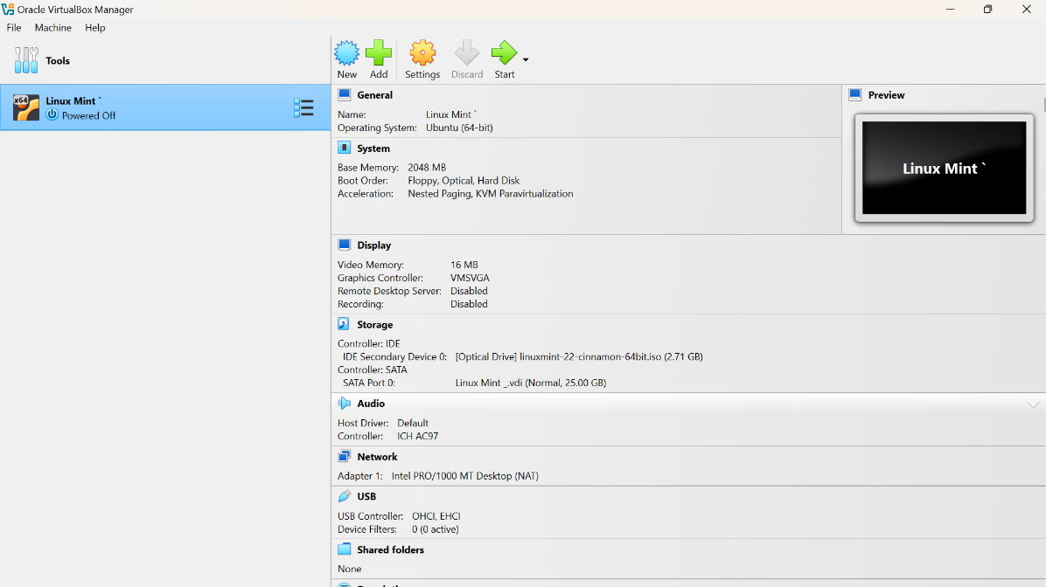

Step 02:

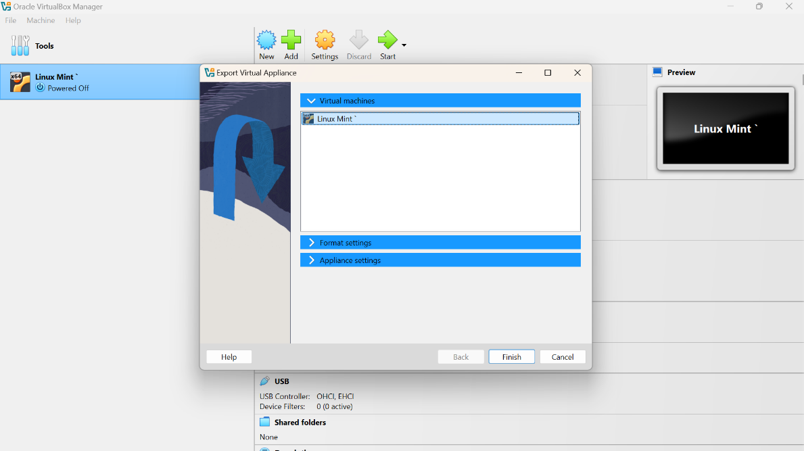

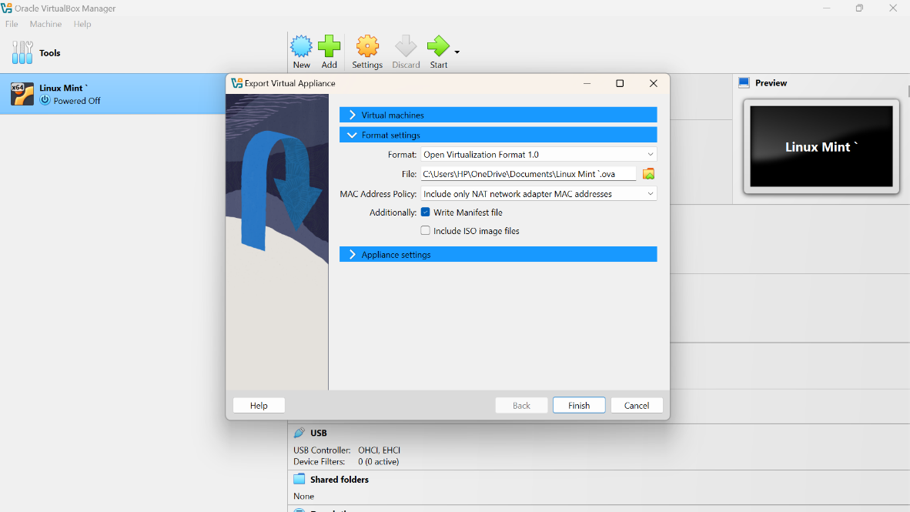

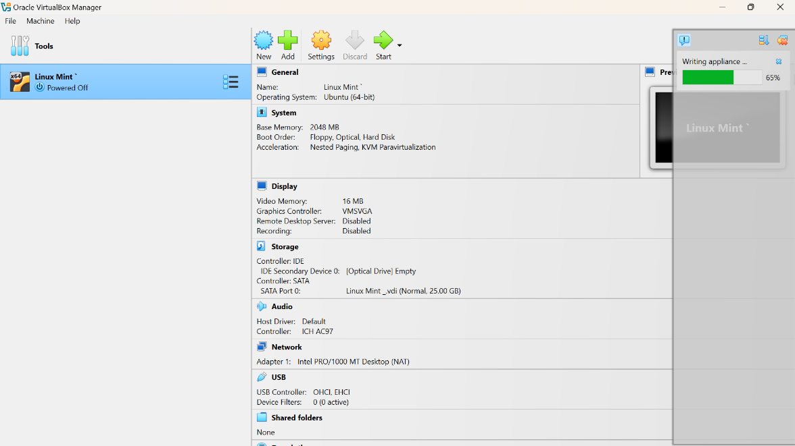

Step 03: Go to ‘File’ and click on the ‘Import Appliance…’ to import your

